
2013
Game Rules: Each team is required to have 1 (and only one) wicket keeper, and a minimum of 4 batsmen and 4 bowlers. All-rounders contribute to both of these minimums, i.e. a team must have 4 people capable of bowling and 4 capable of batting. Transfers: A maximum of 3 transfers will be allowed at any point during the season (provided game rules still met), e-mail address below, call 01437 891440 or text 07833 400697.
Scoring System: Every run scored = 1 point, with a bonus 10 points for scoring 50 in an innings, and a further bonus 10 points for scoring a century. (e.g. 101 runs in an innings = 121 points).
Every wicket taken = 15 pts, with 10 bonus pts for 4 wickets in an innings, and a further 10 pts for taking 6.
Every catch taken = 15 points, and every stumping = 15 points.
Reply by Sunday 28th Apr. £1 entry.
Your Team Name: ……………………………………………
1st Prize £50, 2nd & 3rd prizes – Sunday Lunch for 2 at the Victoria Inn, Roch.

Player Name and Club | Category (Batsman, Bowler etc.) | Price
1)
2)
3)
4)
5)
6)
7)
8)
9)
10)
11)

Total Team Value (£7,500 max)

Your Details:
Your name: ……………………………….. Your Telephone: …………………………………

Your e-mail: …………………………………………………………………………………………

Your address: ………………………………………………………………………………………..

Please return this form by midday Sunday 28th April, e-mail to: kateandandrewmiller@btinternet.com, or post to Pembrokeshire Fantasy Cricket, 21a West Hook Road, Hook, Haverfordwest, Pembrokeshire, SA62 4LS. Don’t worry about sending the entry money by post, just hand me £1 when I see you in the season.
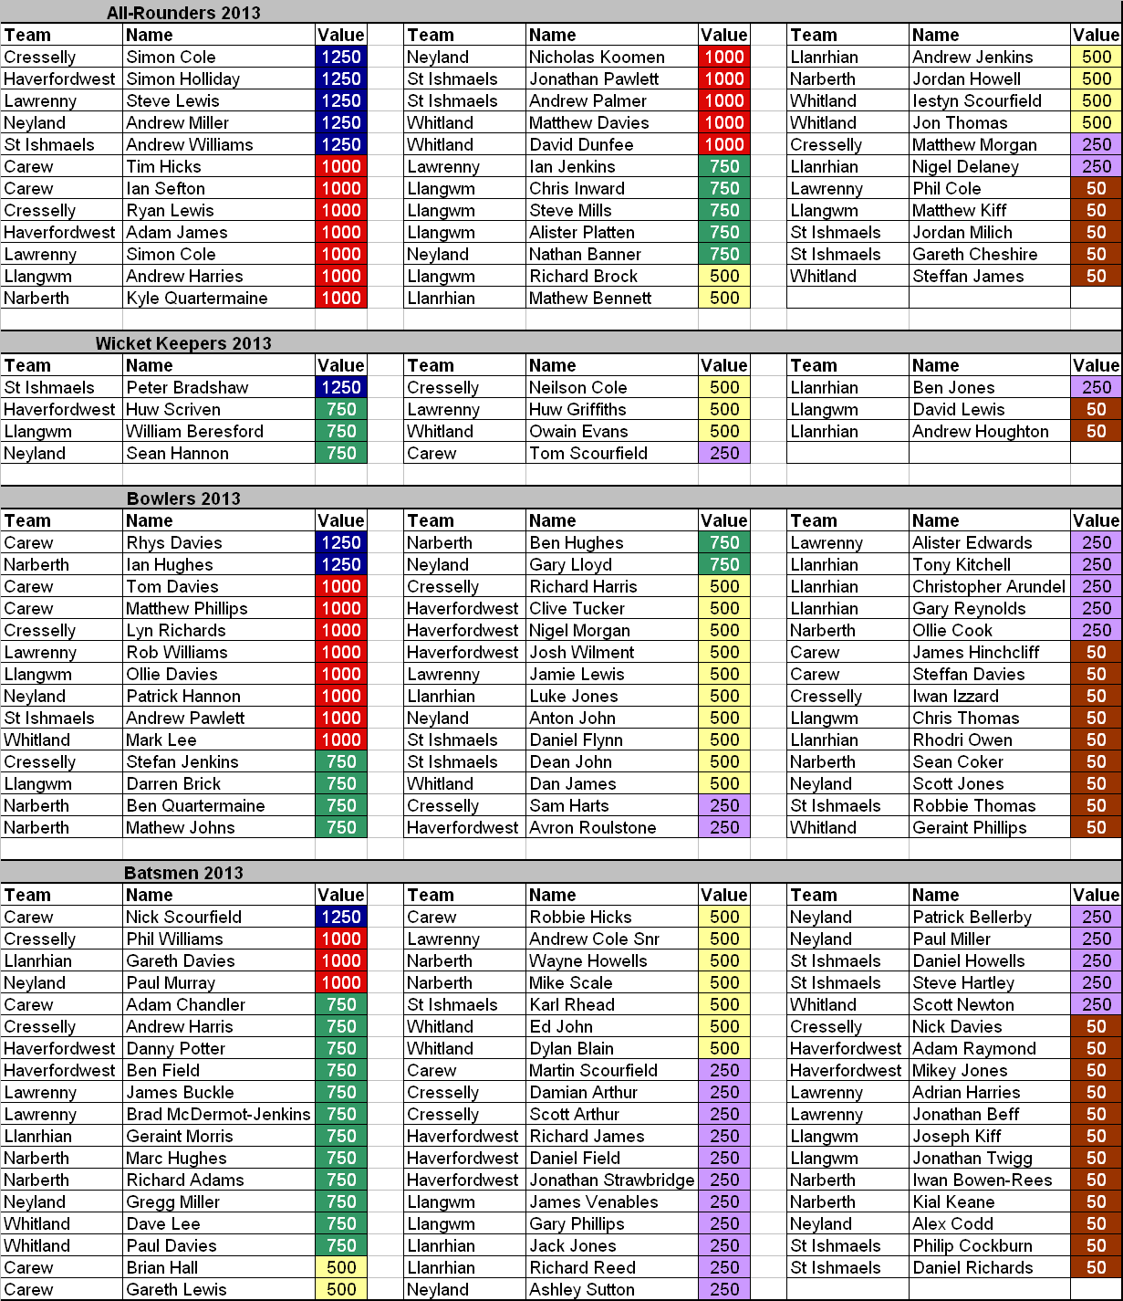

Sponsored
by:

Good home-made Food and real Ales, overlooking St Brides Bay - www.thevictoriainnroch.com

